Market Monitor - South Sudan - 2026-01

Highlights
South Sudan's market outlook for January 2026 remains extremely challenging and pessimistic, characterized by continuous price increases and a rapidly deteriorating humanitarian situation. Food insecurity is projected to worsen significantly across most regions, driven by multiple intersecting crises.
Food Basket Cost: The average cost of a standard food basket increased by ↑2.6% month-on-month and a substantial ↑19.4% year-on-year, reaching SSP 9,256.04.
Key Commodity Prices: Wheat flour, a significant contributor to the overall food basket inflation, saw its price increase by ↑2.6% month-on-month and a notable ↑19.4% year-on-year.
Key Market Drivers:
- Escalating conflict
- Protracted flooding
- Persistently high food prices and inflation
- Deteriorating economic conditions
- Potential public health crises, such as the Marburg Virus Disease
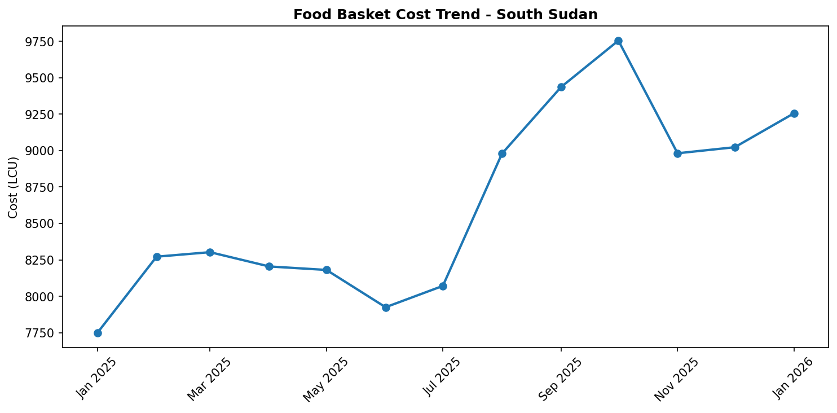
Food basket cost trend

Market Overview
The market outlook for South Sudan in January 2026 remains exceptionally challenging, characterized by a persistent and alarming trajectory of increasing prices across essential commodities. The overall market environment is dominated by a complex interplay of escalating conflict, which continues to displace populations and disrupt trade routes, and the enduring impact of protracted flooding that has damaged infrastructure and agricultural livelihoods. These factors, combined with persistently high food prices and a rapidly deteriorating national economy, are fueling widespread humanitarian distress. A major concern is the projected expansion of Emergency (IPC Phase 4) food insecurity to a staggering 35 counties by May 2026, signaling a severe and worsening crisis across the majority of the country. Adding another layer of vulnerability, the potential for public health crises, exemplified by recent Marburg Virus Disease cases in Kapoeta East County, introduces further risks of market disruption, movement restrictions, and increased fear. High inflation and a collapsing economy will remain the dominant features, exacerbating an already dire situation for millions of South Sudanese households.

Commodity Analysis
Analysis of key food commodities reveals a worrying upward trend, with wheat flour serving as a significant indicator of the overall food basket inflation. In December 2025, wheat flour prices registered a notable 2.6% month-on-month increase, contributing substantially to the rising cost of living. More critically, the year-on-year increase for wheat flour stands at a substantial 19.4%, highlighting the severe and sustained erosion of purchasing power for vulnerable households. This escalating cost for a staple commodity like wheat flour directly reflects the broader challenges gripping the South Sudanese market, including persistent supply disruptions stemming from insecurity and impassable roads due to flooding. Furthermore, the depreciating national currency and the general economic downturn continue to push import costs higher, directly impacting the final consumer prices of essential goods. The sustained increase in wheat flour prices underscores the systemic challenges within the food supply chain and the profound impact of humanitarian crises on market functionality. Without significant intervention, prices for essential commodities are expected to continue their upward trajectory, further deepening the ongoing food security crisis across the nation.
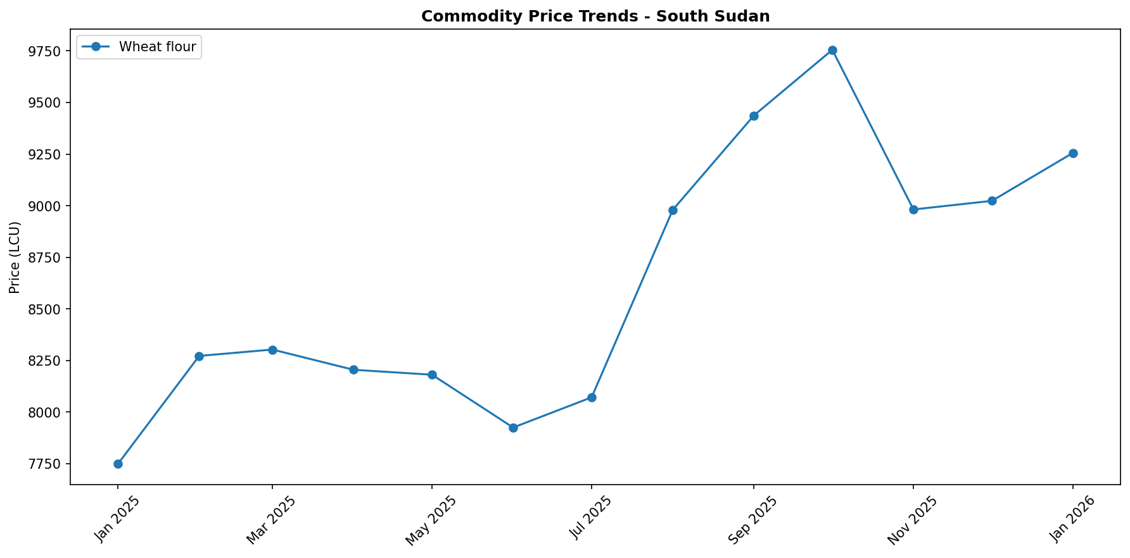

Regional Highlights
The regional market landscape in South Sudan presents a grim picture, with widespread deterioration expected across the country. Nationally, the projection of Emergency (IPC Phase 4) food insecurity expanding to 35 counties by May 2026 underscores a pervasive crisis impacting nearly all regions. This widespread food insecurity is a direct consequence of escalating conflict in various areas, prolonged flooding that has devastated agricultural production and access, persistently high food prices, and an overarching economic decline. Specific regional concerns are also emerging, notably in Kapoeta East County. The reported cases of Marburg Virus Disease in late December 2025, involving individuals with travel history to Ethiopia and potential community spread, pose an immediate public health risk. While currently localized, such outbreaks can lead to swift movement restrictions, reduced economic activity due to fear and isolation, and significant disruptions to local markets, supply chains, and labor availability, further straining already fragile livelihoods if not effectively contained. These regional vulnerabilities collectively contribute to the rapidly deteriorating food security situation observed across South Sudan.
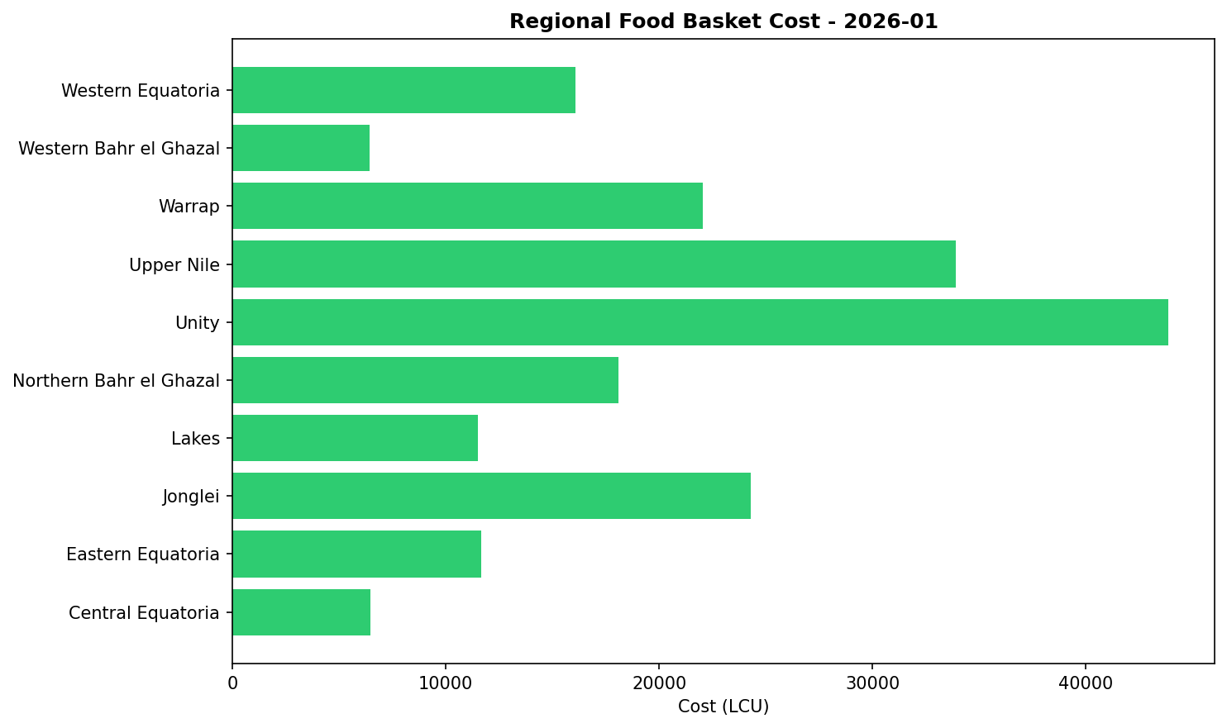

References
- [rw_4193963] ReliefWeb (2026-01-12) Humanitarian Feedback Bulletin: Accountability to Affected Populations - Aweil, South Sudan I November 24 – December 6 2025 / Issue # 12
https://reliefweb.int/node/4193963
- [rw_4193930] ReliefWeb (2026-01-12) South Sudan : MVD Readiness (DREF Operation MDRSS018)
https://reliefweb.int/node/4193930
- [rw_4193581] ReliefWeb (2026-01-08) South Sudan: Food Security Outlook Update: Conflict disrupts humanitarian access, sustaining Emergency and risk of Famine in Nasir, December 2025
https://reliefweb.int/node/4193581
- [rw_4193350] ReliefWeb (2026-01-06) The South Sudan Roadmap on Anticipatory Action 2025 -2030
https://reliefweb.int/node/4193350
- [rw_4193308] ReliefWeb (2026-01-06) South Sudan Joint Market Monitoring Initiative (JMMI) 1 - 7 December 2025
https://reliefweb.int/node/4193308
- [rw_4193074] ReliefWeb (2025-12-31) South Sudan: MSF Evacuates Staff from Lankien Healthcare Facility Following Airstrikes
https://reliefweb.int/node/4193074
- [rw_4193033] ReliefWeb (2025-12-31) WFP South Sudan Country Brief, November 2025
https://reliefweb.int/node/4193033
- [rw_4192953] ReliefWeb (2025-12-30) South Sudan: Humanitarian Snapshot (November 2025)
https://reliefweb.int/node/4192953
- [rw_4192739] ReliefWeb (2025-12-26) South Sudan Health Cluster Strategy 2026
https://reliefweb.int/node/4192739
- [rw_4192527] ReliefWeb (2025-12-23) Norway supports WFP in addressing food needs in South Sudan as levels of food insecurity surge
https://reliefweb.int/node/4192527

